November 2021

Suggested Tweets and Posts for HIP Partners focused on HIP Resources

Quick Content! All Suggested Tweets Ready to be Posted

Monthly, we send you an updated social media guide on the High Impact Practices in Family Planning (HIPs) with the purpose of (1) increasing awareness and use of the HIP briefs, and (2) generating traffic on the HIP website. Beginning in October 2021, we started including posts for sharing on LinkedIn. Please share!

This month’s social media messages are focused on the newly updated Family Planning and Immunization Integration brief. An update from the version originally released in 2013, this service delivery brief details how the extended postpartum period can be a crucial opportunity to provide family planning counseling and services alongside immunization services. Immunization services offer an important opportunity to reach underserved women in the year following delivery, and beyond. Immunization is one of the most widely used health services globally as shown by high vaccination coverage, with approximately one billion children vaccinated over the past decade. The brief provides a theory of change, tips for implementation, indicators, and other essential tools to consider with this high impact practice.

Tweet me!

The extended postpartum period is a great time to reach women with #FamilyPlanning services integrated with child immunization visits. Get tips for implementation in the updated #HIPs4FP brief https://bit.ly/2ZoWV4Z
Just released! An update to the 2013 version of the #HIPs4FP brief on #FamilyPlanning and #Immunization integration, available here https://bit.ly/2ZoWV4Z
Using a #FamilyPlanning and #Immunization integrated service model can be a win-win for clients, providers, and children. Read more in the newly updated #HIPs4FP brief https://bit.ly/2ZoWV4Z
Are you familiar with the service delivery models for integrating #Immunization with #FamilyPlanning services? Read all about them in the newly updated #HIPs4FP brief https://bit.ly/2ZoWV4Z
There are 3 methods of integrating #FamilyPlanning with #Immunization services. Do you know all three -- and how to implement them? The newly updated #HIPs4FP brief shows you how https://bit.ly/2ZoWV4Z

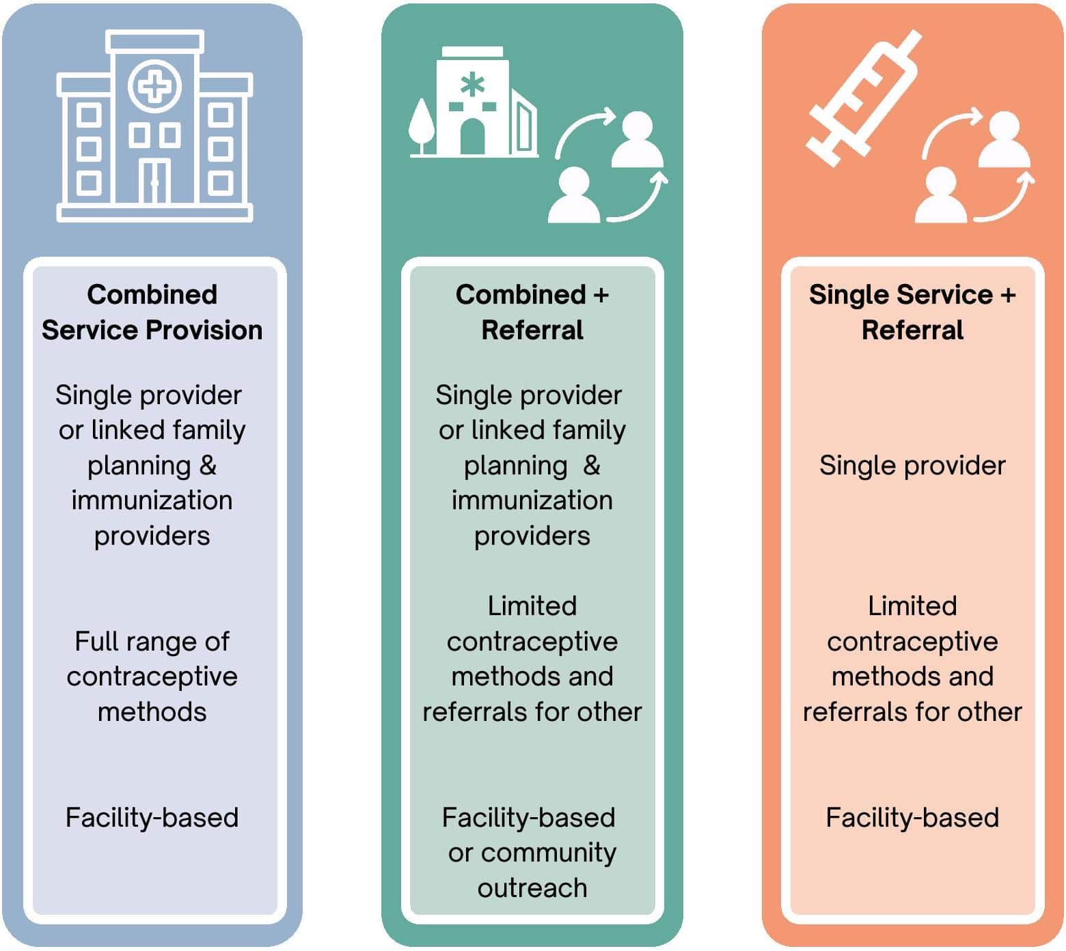
LinkedIn post

Are you familiar with the service delivery models for integrating #Immunization with #FamilyPlanning services? #HIPs4FP just released the updated Family Planning and Immunization Integration brief. An update from the version originally released in 2013, this service delivery brief details how the extended postpartum period can be a crucial opportunity to provide family planning counseling and services alongside immunization services. Immunization services offer an important opportunity to reach underserved women in the year following delivery, and beyond. Immunization is one of the most widely used health services globally as shown by high vaccination coverage, with approximately one billion children vaccinated over the past decade. The brief provides a theory of change, tips for implementation, indicators, and other essential tools to consider with this high impact practice.

This brief was written by: Maria A. Carrasco (USAID), Rebecca Fields (JSI), Linda Ippolito (Strategy2Impact, LLC), Erin Mielke (USAID), Katy Mimno (IntraHealth International), Anne Pfitzer (Jhpiego), Shannon Pryor (Save the Children), Kate Rademacher (FHI 360), and Deborah Samaila Hassan (JHU/CCP).

