April 2021

Suggested Tweets for HIP Partners focused on the
Dissemination and Engagement

Quick Content! All Suggested Tweets Ready to be Posted

Monthly, we send you an updated social media guide on the High Impact Practices in Family Planning (HIPs) with the purpose of (1) increasing awareness and use of the HIP briefs, and (2) generating traffic on the HIP website. Please share!

Tweet me!

The #HIPs4FP are strengthened by broad engagement from the global #familyplanning community. How can YOU engage with #HIPs4FP? Learn about the various opportunities:
https://www.fphighimpactpractices.org/engage-with-the-hips/
Your #familyplanning expertise helps create stronger #HIPs4FP. Check out the briefs open for community feedback, and share your thoughts: https://www.fphighimpactpractices.org/community-feedback-on-hip-briefs/
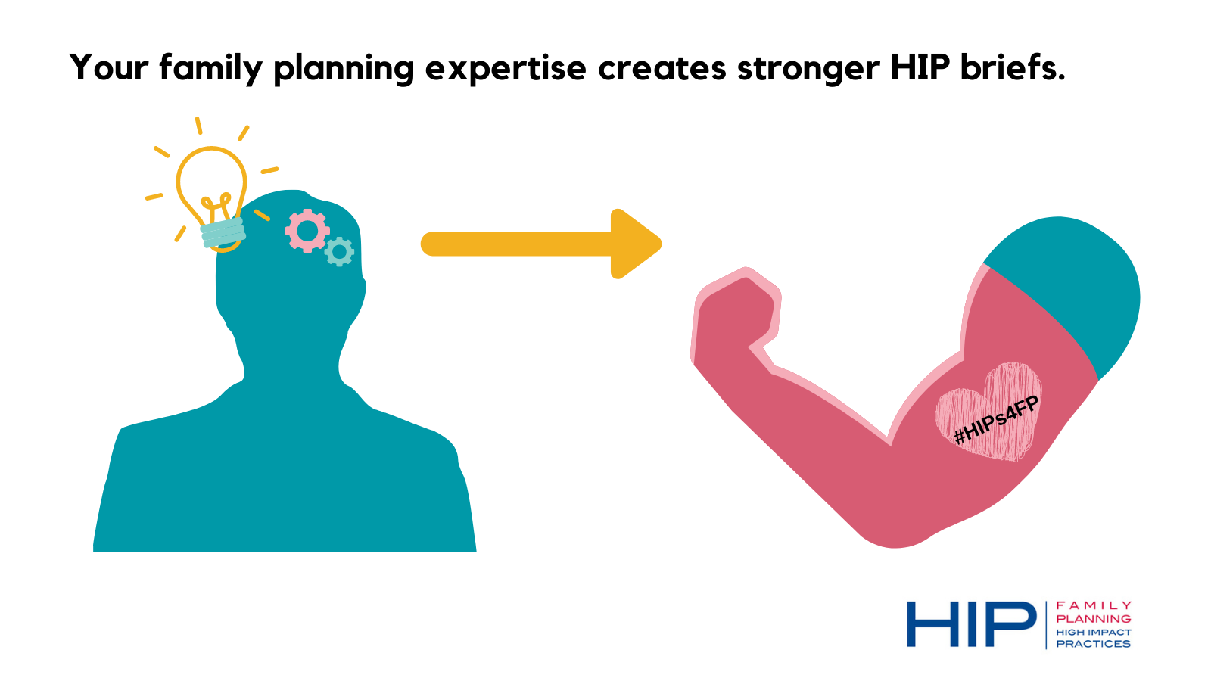
As evidence evolves, so do the #HIPs4FP. We need your expert #familyplanning feedback on recently updated briefs! https://www.fphighimpactpractices.org/community-feedback-on-hip-briefs/
Register now for GHTechX & attend the #HIPs4FP session on 23 April at 10:15am EST. Advisors from @FP2030 @IBPnetwork @PathfinderInt @USAIDGH will tell the story of the #HIPs4FP Partnership and its contribution to advancing evidence-based programming. https://globalhealthxchange.com/2021-info/
Are you registered for GHTechX? Attend the session on 22 April at 8 EST highlighting applications of #HIPs4FP during #COVID19 and hear from #familyplanning experts from East and Southern Africa. https://globalhealthxchange.com/2021-info/

