March 2021

Updated - HIP Adolescent-Responsive Contraceptive Services

There is evidence that adolescent-friendly services, when well-designed and well-implemented, can help increase access to and use of contraception. However, traditional models of specialized service delivery for adolescents have proven difficult to sustain and scale. Establishing adolescent-responsive contraceptive services (ARCS) is emerging as a more scalable and sustainable way to meet adolescents’ needs for contraceptive information and services. The term adolescent-responsive contraceptive services (ARCS) signals an evolution from traditional stand-alone models of adolescent-friendly services towards a systems approach to making existing contraceptive services adolescent-responsive by incorporating elements with demonstrated effectiveness for increasing adolescent contraceptive use. A systems approach implies that policies, procedures, and programs across the entire health system are adapted to respond to the diverse needs and preferences of adolescents.

Adolescent-Responsive Contraceptive Services (ARCS) has been identified as a HIPs Enhancement—a practice that is not typically a standalone intervention, but rather implemented in conjunction with HIPs to further intensify the impact of the HIPs. Examples of how HIPs can be enhanced through the inclusion of adolescent-responsive elements include offering contraceptive information and methods to adolescent mothers during routine child immunizations (Family planning and immunization integration), vouchers for free services to offset financial barriers for youth and adolescents and targeted demand generation (Social franchising), and community health workers trained to counsel and refer married adolescents for contraception during household visits (Community health workers).

Download the HIP Adolescent-Responsive Contraceptive Services brief and visit www.fphighimpactpractices.org to learn more about High Impact Practices in Family Planning.

Key Points: Adolescent-Responsive Contraceptive Services

- Many countries continue to use approaches for adolescent contraceptive services are either ineffective at increasing contraceptive use (e.g., youth centers) demonstrate mixed effects (peer education) or are challenging to sustain and bring to scale (separate spaces for young people within health facilities) and contribute to poor sexual and reproductive health outcomes.
- Establishing adolescent-responsive contraceptive services (ARCS) is emerging as a more scalable and sustainable way to meet adolescents’ needs for contraceptive information and services.
- Adolescent-responsive contraceptive services means applying a systems approach to make existing contraceptive services responsive to the needs and preferences of adolescents, i.e., incorporating evidence-based elements throughout all components of the health system, rather than implementing isolated interventions.
- A systems-approach to adolescent-responsive contraceptive services is necessary to address the multiple barriers to adolescent’s access and use of contraceptive services: laws and policies; gender and social norms; misconceptions and lack of knowledge; financial barriers; lack of privacy and confidentiality; and provider bias.
- Lessons from Chile, Ethiopia, and Uruguay show that when an adolescent-responsive leans is intentionally and systematically applied across the health system, the resulting system is stronger and is better able to sustain quality services at scale.
- Implementation tips include: ensure an enabling policy and legal environment for contraceptive provision to adolescents; employ a variety of sectors and channels to reach different adolescent segments for service delivery; and improve providers’ competency in providing adolescent-responsive contraceptive services.
- Additional tips are to: collect and use data to design, improve, and track ARCS implementation; address financial barriers to adolescent contraceptive use, and support meaningful participation and leadership of adolescents.

Suggested Tweets for HIP Partners focused on the
HIP Adolescent-Responsive Contraceptive Services brief
Quick Content! All Suggested Tweets Ready to be Posted

Tweet me!

What does the evolution from adolescent-friendly to adolescent-responsive contraceptive services look like? Learn more at the newly published #HIPs4FP brief: https://www.fphighimpactpractices.org/briefs/adolescent-responsive-contraceptive-services/
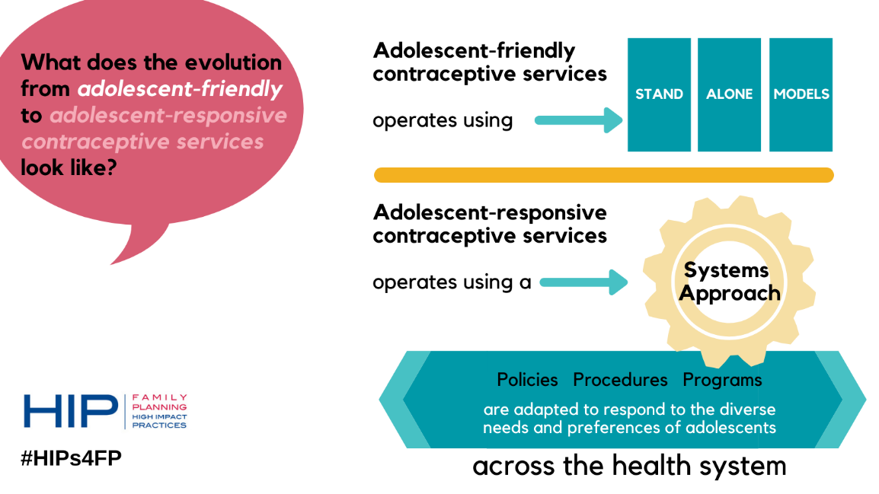
Did you know? Adolescent-responsive contraceptive services are deemed scalable & sustainable in meeting adolescents’ needs for contraceptive info & services. Learn more: https://www.fphighimpactpractices.org/briefs/adolescent-responsive-contraceptive-services/ #HIPs4FP
JUST RELEASED! The new adolescent #HIPs4FP Enhancement brief can be implemented in conjunction with other high-impact practices to further intensify their impact. Learn more: https://www.fphighimpactpractices.org/briefs/adolescent-responsive-contraceptive-services/
Adolescents face many barriers in accessing contraceptive services. Health systems must institutionalize service delivery that acknowledges them as distinct from other groups. Learn more about the adolescent-responsive approach in the #HIPs4FP brief. https://www.fphighimpactpractices.org/briefs/adolescent-responsive-contraceptive-services/
Ethiopia & Chile have taken actions to improve adolescent contraceptive use through adolescent-responsive contraceptive services and are showing promising results. Find out more about those specific actions in the updated #HIPs4FP brief. https://www.fphighimpactpractices.org/briefs/adolescent-responsive-contraceptive-services/
Need tips to understand how to implement adolescent-responsive contraceptive services in your program? Come check out the newly updated #HIPs4FP brief. https://www.fphighimpactpractices.org/briefs/adolescent-responsive-contraceptive-services/
