December 2020

New - HIP Digital Health to Support Family Planning Providers

Digital health tools can help family planning providers deliver a higher quality of care through job aids, communication tools, training, and data. This new High Impact Practices in Family Planning (HIP) brief uses the WHO definition of digital health from the draft Global Strategy on Digital Health 2020-2024: “the field of knowledge and practice associated with the development and use of digital technologies to improve health.” Therefore, the recommendations include mhealth (“medical and public health practice supported by mobile devices”) and ehealth (“the use of information and communication technologies for health”) interventions. Of the six building blocks of health systems identified by the WHO, this brief focuses on the first, service delivery, specifically on the ways that digital health can support service providers to deliver quality contraceptive services.

Digital Health to Support Family Planning Providers has been identified as a HIPs Enhancement—a practice that is not typically a standalone intervention, but rather implemented in conjunction with HIPs to further intensify the impact of the HIPs. For example, a growing body of evidence indicates that use of digital tools by providers supports a range of functions including registration, health data collection and reporting to improve continuity of care, and improved adherence to treatment approaches. Indeed, use of digital tools by providers promotes consistent and successful adherence to evidenced-based service delivery protocols.

Download the HIP Digital Health to Support Family Planning Providers brief and visit www.fphighimpactpractices.org to learn more about High Impact Practices in Family Planning.

Theory of Change for Digital Health Enhancements

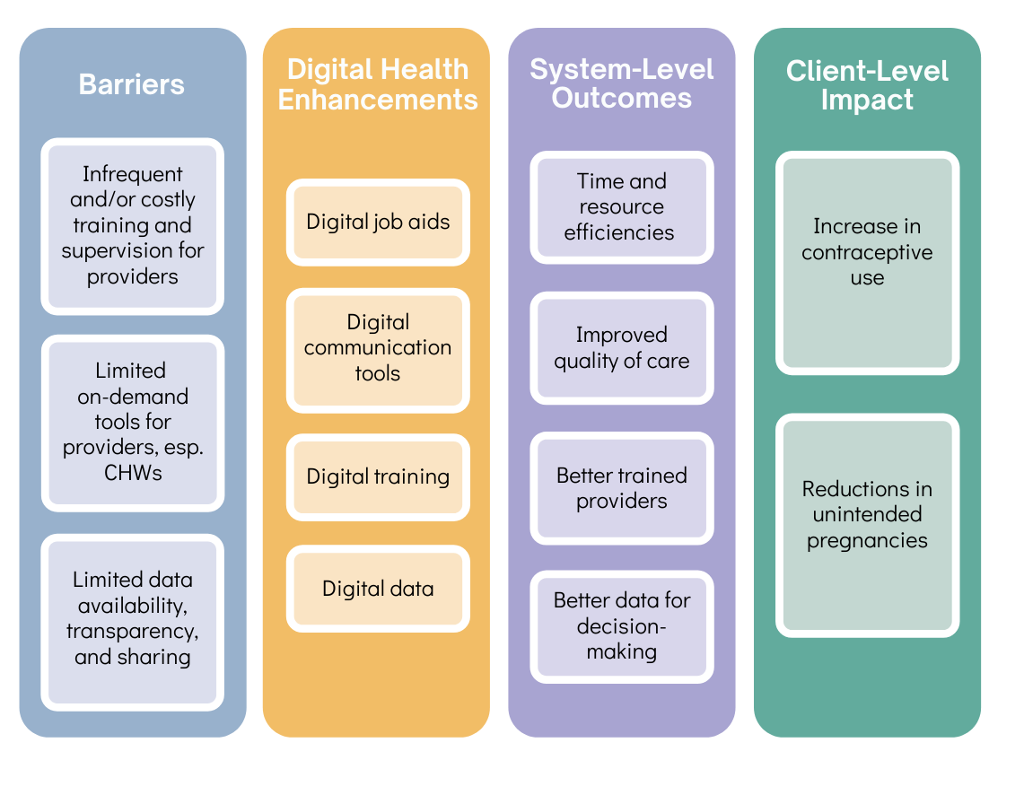

Key Points: Digital Health to Support Family Planning Providers
- A review of the literature shows that four digital health enhancements in particular may increase quality of family planning services: 1) job aids, 2) communication tools, 3) training, and 4) data.
- The body of evidence specific to the impact of digital resources on family planning outcomes is still growing; however, results from other health areas are encouraging.
- Digital clinical decision support systems (CDSS), accessed via mobile devices, may improve family planning service providers’ adherence to clinical guidelines and interactions with clients, including service linkages/referrals and continued method use.
- Use of remote communication via SMS, calls, and mobile-based modules can promote more frequent and supportive provider supervision and encourage clients to submit honest feedback on their experiences.
- As a complement to in-person trainings, digital applications can improve clinical knowledge through refresher trainings and continuous learning opportunities for service providers.
- Real-time digital data collection on both clients and logistics can aid with continuity of care at the individual level and efficient resource planning at the population level.
- Well-resourced urban areas often benefit from robust digital infrastructures, which can exacerbate inequities as more data will be collected in advantaged areas compared to disadvantaged areas.
Suggested Tweets for HIP Partners focused on the
Digital Health to Support Family Planning Providers brief

Quick Content! All Suggested Tweets Ready to be Posted

Tweet me!

- #digitalhealth is a #HIPs4FP enhancement that can maximize the impact of #familyplanning programs by supporting providers. Learn more: https://www.fphighimpactpractices.org/briefs/digital-health-to-support-family-planning-providers/ #ehealth #mhealth
- Job aids, communication, training, data: just a few of the ways #digitalhealth helps #familyplanning providers deliver high-quality care. Learn more: https://www.fphighimpactpractices.org/briefs/digital-health-to-support-family-planning-providers/ #HIPs4FP #ehealth #mhealth
- How can expanding cellular networks improve #familyplanning outcomes? Learn more about #digitalhealth investments: https://www.fphighimpactpractices.org/briefs/digital-health-to-support-family-planning-providers/ #HIPs4FP #ehealth #mhealth
- #CHWs in India reported that digital job aids led to increased confidence. Learn more about #digitalhealth for #familyplanning: https://www.fphighimpactpractices.org/briefs/digital-health-to-support-family-planning-providers/ #HIPs4FP #ehealth #mhealth
- In Malawi, #SMS helped #CHWs receive timely support and feedback from supervisors. How else can #digitalhealth support #familyplanning providers? https://www.fphighimpactpractices.org/briefs/digital-health-to-support-family-planning-providers/ #HIPs4FP #ehealth #mhealth
- Training for #familyplanning providers can go digital, complementing in-person learning. https://www.fphighimpactpractices.org/briefs/digital-health-to-support-family-planning-providers/ #HIPs4FP #ehealth #mhealth #digitalhealth
- Digital data means efficient planning and fewer stockouts. Learn more about #digitalhealth for #familyplanning providers: https://www.fphighimpactpractices.org/briefs/digital-health-to-support-family-planning-providers/ #HIPs4FP #ehealth #mhealth

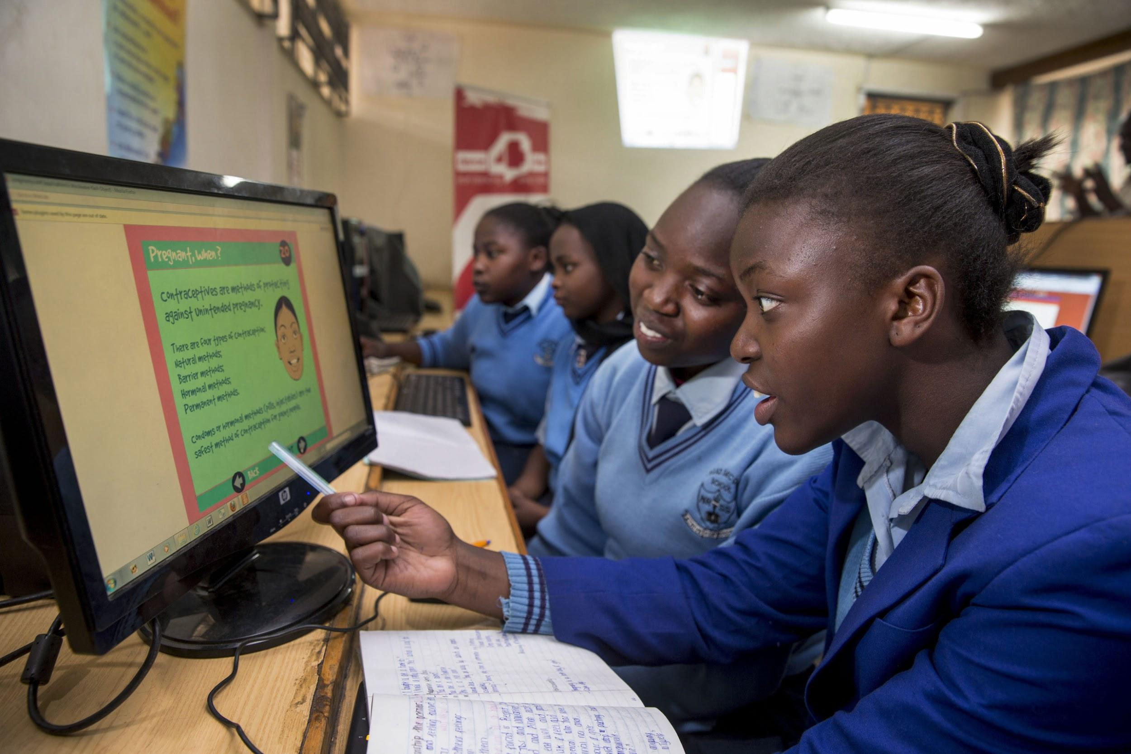
Girls participating in a sexual reproductive health class supported by Dance4Life at Nile Road Secondary School in Nairobi, Kenya. Dance4Life Uses music, media and dance to educate, empower, and unite young girls in taking action and improving sexual health. Jonathan Torgovnik/Getty Images/Images of Empowerment
© 2012 Marcel Reyners, Courtesy of Photoshare

