October 2020

Suggested Tweets for HIP Partners focused on the Economic Empowerment evidence summary

Quick Content! All Suggested Tweets Ready to be Posted

Monthly, we send you an updated social media guide on the High Impact Practices in Family Planning (HIPs) with the purpose of (1) increasing awareness and use of the HIP briefs, and (2) generating traffic on the HIP website. Please share!

Tweet me!

Economic empowerment interventions can address #familyplanning barriers, promote equitable gender norms, and lead to better overall health outcomes:
https://www.fphighimpactpractices.org/briefs/economic-empowerment/
#HIPs4FP #DayofTheGirl #RuralWomen
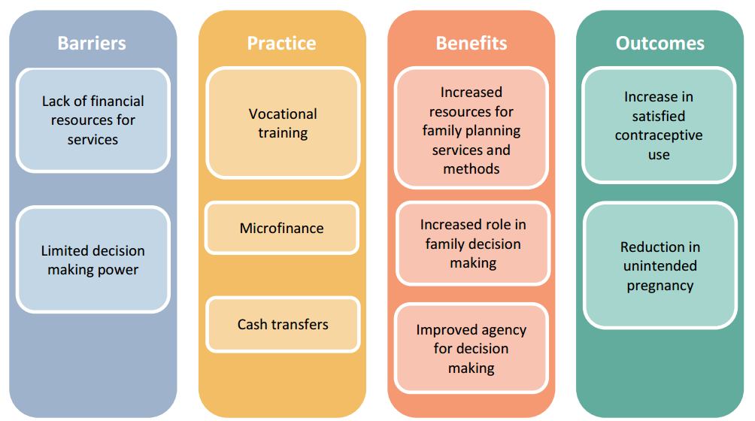
Empowerment includes agency, resources, and achievements. Learn why all three are critical to supporting women and girls to meet their #familyplanning goals:
https://www.fphighimpactpractices.org/briefs/economic-empowerment/ #HIPs4FP #DayofTheGirl #RuralWomen
When women are empowered economically, they have greater control over their #familyplanning choices. And that leads to greater prosperity for everyone.
https://www.fphighimpactpractices.org/briefs/economic-empowerment/ #HIPs4FP #DayofTheGirl #RuralWomen
Vocational training is one form of economic empowerment. Learn about others: https://www.fphighimpactpractices.org/briefs/economic-empowerment/ #HIPs4FP #familyplanning #DayofTheGirl #RuralWomen
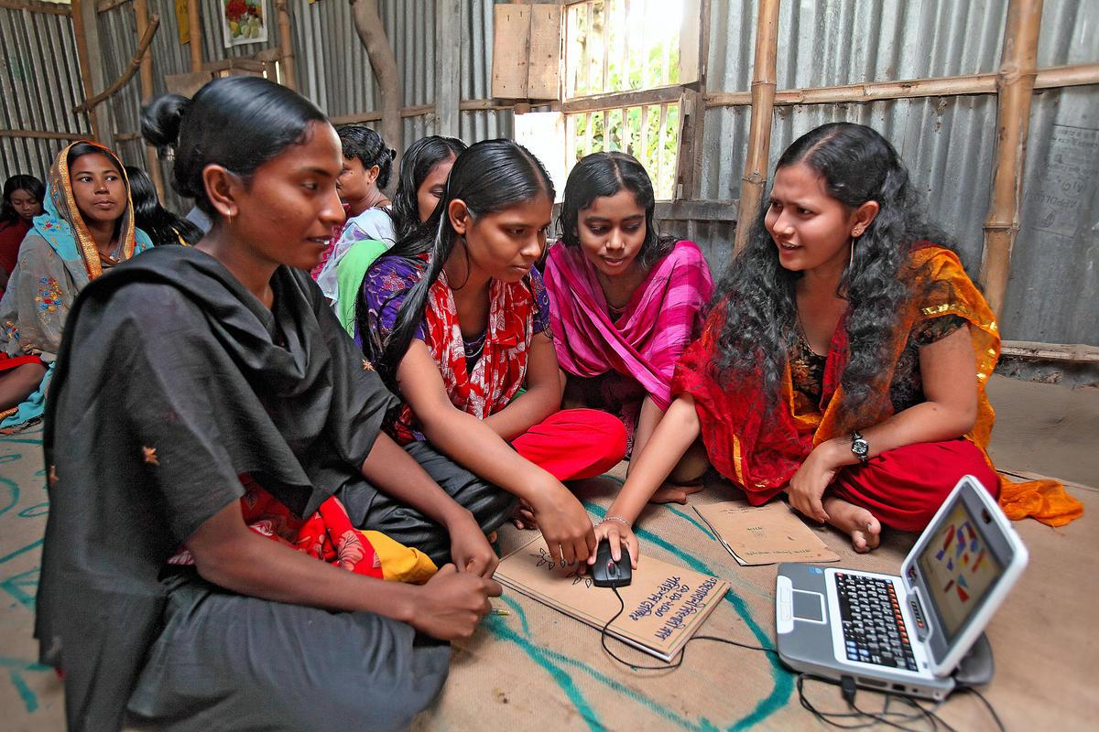
Adolescent girls have fun learning how to use a computer in Gondohali village, Bangladesh. © 2010 Sumon Yusuf, Courtesy of Photoshare.
In Namibia and Uganda, researchers found a positive correlation between women’s economic empowerment and #familyplanning use. Learn more:
https://www.fphighimpactpractices.org/briefs/economic-empowerment/ #HIPs4FP #DayofTheGirl #RuralWomen
Vocational training, microfinance, cash transfers: how do these economic empowerment interventions affect #familyplanning for women and girls? https://www.fphighimpactpractices.org/briefs/economic-empowerment/ #HIPs4FP #DayofTheGirl #RuralWomen
Girls who participated in a Bangladesh vocational training program were 23%-31% less likely to be married as children. Learn more about the benefits of economic empowerment:
https://www.fphighimpactpractices.org/briefs/economic-empowerment/ #HIPs4FP #familyplanning #DayofTheGirl #RuralWomen
Girls often lag behind boys in the formal labor market, with ripple effects. Learn how economic empowerment approaches can help make a difference: https://www.fphighimpactpractices.org/briefs/economic-empowerment/ #HIPs4FP #familyplanning #DayofTheGirl #RuralWomen

