July 2020

Updated - HIP Family Planning Vouchers: A tool to boost contraceptive method access and choice

This updated High Impact Practices in Family Planning (HIP) brief discusses the potential contributions of vouchers to enhancing the quality and voluntary use of contraceptive services. Health care vouchers are paper or electronic referral coupons that clients can take to an accredited health care provider in exchange for health care services. In settings where potential clients must pay for contraceptive services and/or methods, they may face financial barriers that restrict their ability to access and use some methods. Vouchers can reduce these financial barriers and facilitate client access to more contraceptive options.

Vouchers are a HIPs Enhancement—a practice that is not typically a standalone intervention, but rather implemented in conjunction with HIPs to further intensify the impact of the HIPs. For example, vouchers can enhance social franchising by supporting client-centered access to contraceptive products and services, including adolescent-friendly contraceptive services, through preferred and convenient service delivery points including the private sector. Vouchers can enhance community health workers by disseminating key information about contraceptives, services, and how to access them, as well as addressing other non-financial barriers.

Download the HIP Family Planning Vouchers brief and visit www.fphighimpactpractices.org to learn more about High Impact Practices in Family Planning.

Model illustrating how voucher programs work

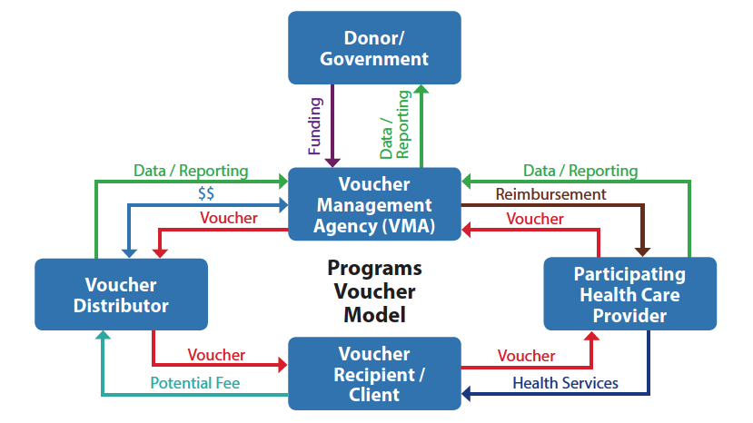

Key Points: Family Planning Vouchers: A tool to boost contraceptive method access and choice
- Vouchers are paper or electronic referral coupons that clients can take to an accredited health care provider in exchange for health care services.
- Providing vouchers to clients can facilitate equitable access to and choice of voluntary contraceptive services.
- Vouchers can reduce financial barriers to accessing contraceptives and services particularly for the poor and adolescents.
- By reducing financial barriers to contraceptive services, vouchers can also expand client choice and make private providers an option for disadvantaged clients previously restricted by cost.
- Vouchers can serve to disseminate key information about contraceptives, services, and how to access them, as well as addressing other non-financial barriers.
- Vouchers can improve the quality of service provision

Suggested Tweets for HIP Partners focused on the
Family Planning Vouchers brief

Quick Content! All Suggested Tweets Ready to be Posted

Tweet me!

- Vouchers are a #HIPs4FP enhancement that can maximize the impact of #familyplanning programs. Learn more: https://www.fphighimpactpractices.org/briefs/family-planning-vouchers/
- Where #familyplanning clients face barriers to access/services, vouchers can help: https://www.fphighimpactpractices.org/briefs/family-planning-vouchers/ #HIPs4FP
- Vouchers support #familyplanning providers through encouraging #qualityimprovement, inc. capacity strengthening and accountability: https://www.fphighimpactpractices.org/briefs/family-planning-vouchers/ #HIPs4FP
- In Nicaragua, adolescents with #familyplanning vouchers had 3.1 higher odds of using participating health centers than their peers. Learn more: https://www.fphighimpactpractices.org/briefs/family-planning-vouchers/ #HIPs4FP
- Voucher programs work best when they include a range of services in addition to #familyplanning. #STI testing/treatment and #postpartum care also benefit clients! https://www.fphighimpactpractices.org/briefs/family-planning-vouchers/ #HIPs4FP
- Vouchers for specific #familyplanning methods (ex. #LARCs) can promote method choice and reduce barriers inc. client demand, provider shortages, and stockouts. Learn more: https://www.fphighimpactpractices.org/briefs/family-planning-vouchers/ #HIPs4FP
- #familyplanning vouchers support other #HIPs4FP implementation. Vouchers + #socialfranchising = greater client access. Learn more: https://www.fphighimpactpractices.org/briefs/family-planning-vouchers/
- In Pakistan, a #familyplanning voucher program relied on #communityhealthworkers to raise awareness and counsel clients. Learn why this worked so well: https://www.fphighimpactpractices.org/briefs/family-planning-vouchers/ #HIPs4FP

Photo showing women with vouchers in clinic

