March 2020

Suggested Tweets for HIP Partners focused on the Discussion Paper on Equity

Quick Content! All Suggested Tweets Ready to be Posted

Monthly, we send you an updated social media guide on the High Impact Practices in Family Planning (HIPs) with the purpose of (1) increasing awareness and use of the HIP briefs, and (2) generating traffic on the HIP website. Please share!

Tweet me!

The EQUITY framework developed by @HlthPolicyPlus can help reduce gaps in #familyplanning programming. Learn more: https://www.fphighimpactpractices.org/wp-content/uploads/2019/10/HIP-Equity-Discussion-Paper.pdf #HIPs4FP
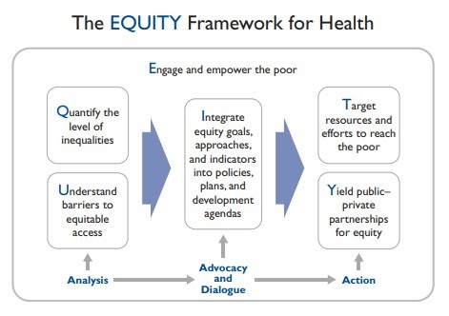
Read how the HIP Partnership is conceptualizing, defining, and measuring dimensions of equity for #familyplanning programs:
https://www.fphighimpactpractices.org/wp-content/uploads/2019/10/HIP-Equity-Discussion-Paper.pdf #HIPs4FP
Working towards equity in #familyplanning means understanding social determinants for health. @WHO developed a framework for this. Learn more: https://www.fphighimpactpractices.org/wp-content/uploads/2019/10/HIP-Equity-Discussion-Paper.pdf #HIPs4FP
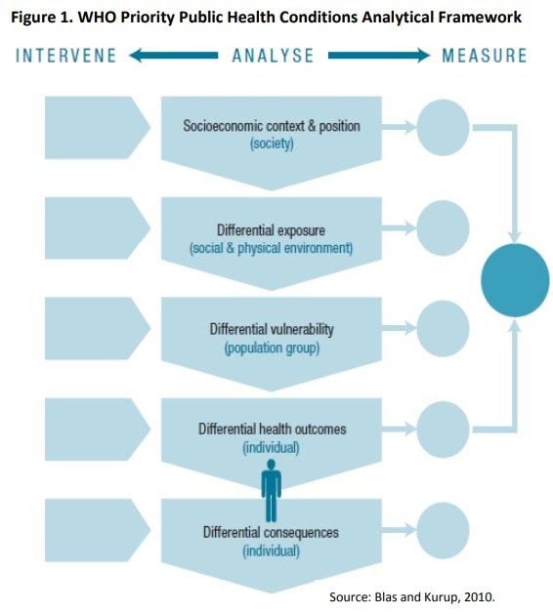
Equity and equality aren’t the same, but we need both to develop high-quality #familyplanning programs:
https://www.fphighimpactpractices.org/wp-content/uploads/2019/10/HIP-Equity-Discussion-Paper.pdf #HIPs4FP
#Equity is one of the HIP Partnership’s 8 guiding principles and an important #familyplanning consideration:
https://www.fphighimpactpractices.org/wp-content/uploads/2019/10/HIP-Equity-Discussion-Paper.pdf #HIPs4FP
Hearing a lot about #equity, but wondering how it’s defined for health and #familyplanning? That’s why the HIP Partnership wrote a paper on it: https://www.fphighimpactpractices.org/wp-content/uploads/2019/10/HIP-Equity-Discussion-Paper.pdf/ #HIPs4FP

