June 2020

Suggested Tweets for HIP Partners focused on Support for COVID-19 Efforts

Quick Content! All Suggested Tweets Ready to be Posted

Monthly, we send you an updated social media guide on the High Impact Practices in Family Planning (HIPs) with the purpose of (1) increasing awareness and use of the HIP briefs, and (2) generating traffic on the HIP website. This month, rather than highlighting a single brief, we are focusing on the ways in which HIPs can support COVID-19 treatment and recovery programs. Please share!

Tweet me!

Advocate to waive policies that block access to #familyplanning services (residency reqs, couple registration, etc.) during a crisis: https://www.fphighimpactpractices.org/guides/family-planning-in-humanitarian-settings/ #HIPs4FP #COVID19
Learn how to to mobilize resources to strengthen the delivery of routine #familyplanning services in crisis-affected areas and beyond: https://www.fphighimpactpractices.org/guides/family-planning-in-humanitarian-settings/ #HIPs4FP #COVID19
A healthy #supplychain is critical to ensuring #familyplanning availability--never more so than during the #COVID19 pandemic. Learn more: https://www.fphighimpactpractices.org/briefs/supply-chain-management/ #HIPs4FP
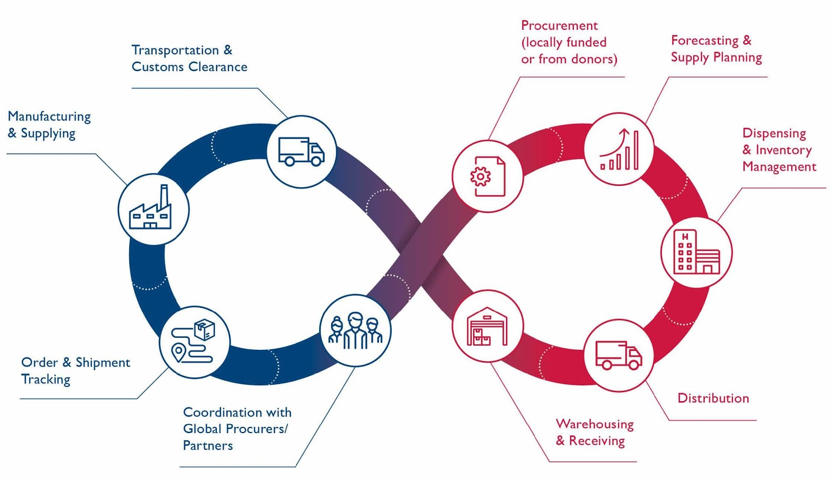
In a crisis like #COVID19, #stockouts can occur and leave #familyplanning clients without their method. Learn how investing in #supplychain management can help: https://www.fphighimpactpractices.org/briefs/supply-chain-management/ #HIPs4FP
Community #healthworkers are one of the most effective solutions to #humanresources for health shortages--crucial in a crisis like #COVID19 to ensure access to #familyplanning. https://www.fphighimpactpractices.org/briefs/community-health-workers/ #HIPs4FP
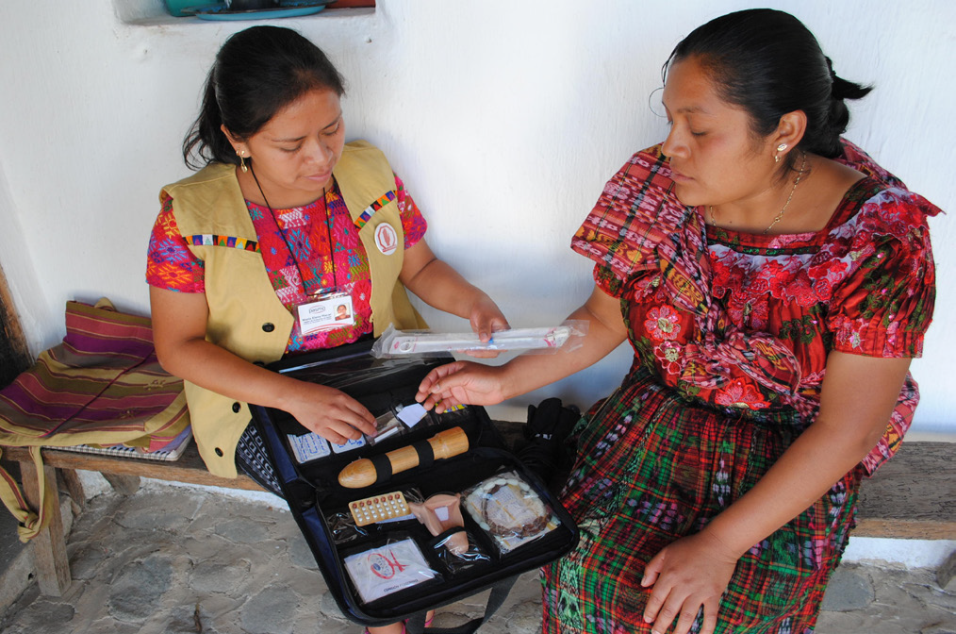
Community #healthworkers meet people where they are with #familyplanning information, services, and supplies. That's never been more important: https://www.fphighimpactpractices.org/briefs/community-health-workers/ #COVID19 #HIPs4FP
Mobile outreach can expand access to a full range of modern #familyplanning methods anytime, but especially during a crisis: https://www.fphighimpactpractices.org/briefs/mobile-outreach-services/ #COVID19 #HIPs4FP
Mobile outreach ensures flexible, strategic deployment of #familyplanning resources when and where they're needed most: https://www.fphighimpactpractices.org/briefs/mobile-outreach-services/ #COVID19 #HIPs4FP

