April 2020

Suggested Tweets for HIP Partners focused on the Community Health Workers and FP-Immunization Integration Briefs

Quick Content! All Suggested Tweets Ready to be Posted

Monthly, we send you an updated social media guide on the High Impact Practices in Family Planning (HIPs) with the purpose of (1) increasing awareness and use of the HIP briefs, and (2) generating traffic on the HIP website. You'll note hashtags associated with relevant April observances: World Health Worker Week, World Health Day, and World Immunization Week. Please share!

Tweet me!

This month, we honor health workers. Community health workers improve access to #familyplanning among hard-to-reach groups. #WHWWeek #WorldHealthDay #HIPs4FP
https://www.fphighimpactpractices.org/briefs/community-health-workers/

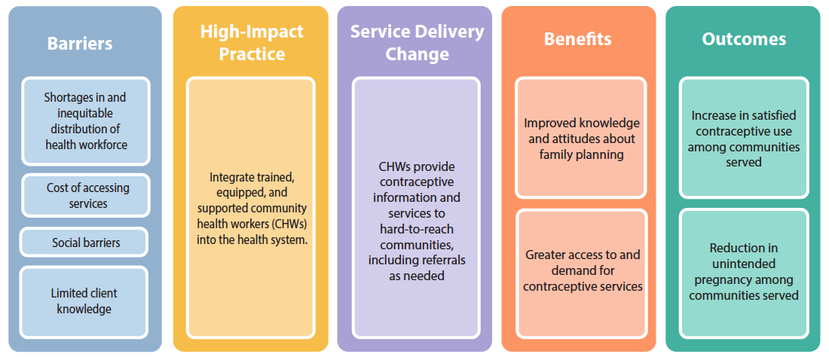
Community health workers can help countries address a variety of #familyplanning challenges, including financial, social, and geographic. Learn more:
https://www.fphighimpactpractices.org/briefs/community-health-workers/ #HIPs4FP #WHWWeek #WorldHealthDay
Community health workers overcome #familyplanning barriers by bringing services to women where they work and live. Learn more: https://www.fphighimpactpractices.org/briefs/community-health-workers/ #HIPs4FP #WHWWeek #WorldHealthDay

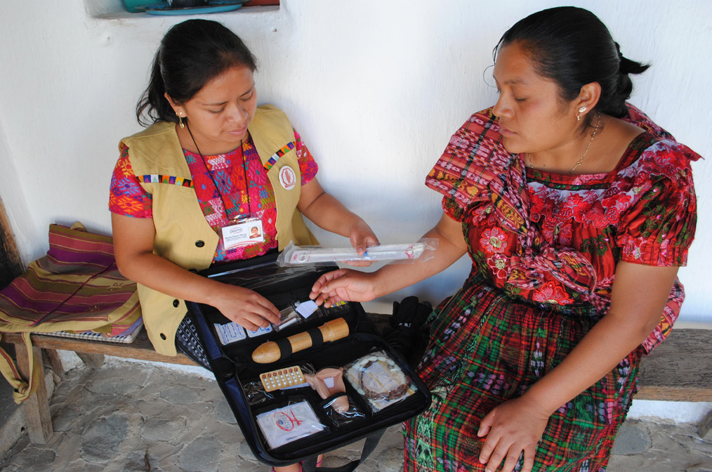
Offering #familyplanning info and services to postpartum mothers during routine child #immunization visits is a promising #HIPs4FP:
https://www.fphighimpactpractices.org/briefs/family-planning-and-immunization-integration/ #VaccinesWork
Different #familyplanning + #immunization models meet different needs:
https://www.fphighimpactpractices.org/briefs/family-planning-and-immunization-integration/ #HIPs4FP #VaccinesWork
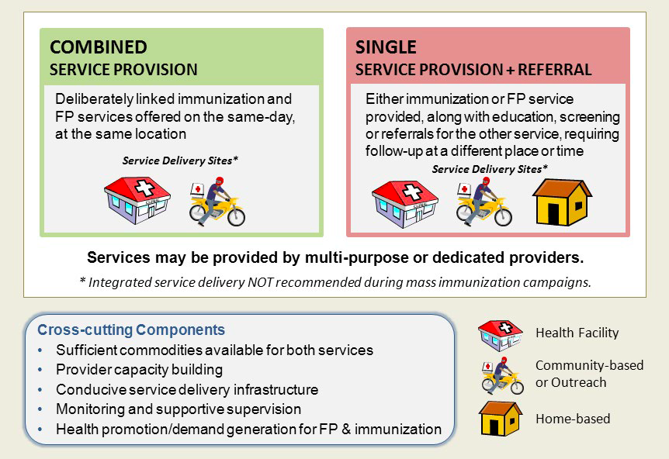
Caring for mothers and babies is what #familyplanning + #immunization integration is all about. Learn more: https://www.fphighimpactpractices.org/briefs/family-planning-and-immunization-integration/ #HIPs4FP #VaccinesWork
